¹⁷⁷Lu DOTATATE Kidney dosimetry calculation workshop
A 5 year old paediatric patient has been administered a weight based activity of ¹⁷⁷Lu-DOTATATE (75MBq x patient weight). The intention is to give 4 fractions of ¹⁷⁷Lu-DOTATATE, with the activities prescribed so as to keep the cumulative kidney dose below 23Gy. Therefore, from the fraction 1 data, we can calculate activity to be administered for subsequent fractions such that the kidney dose constraint is not exceeded.
The following post-therapy imaging has been performed:
A series of 3 whole-body scans
A series of 3 SPECT/CT acquisitions
Whole-body scans
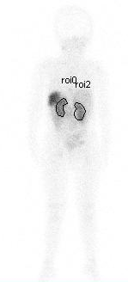
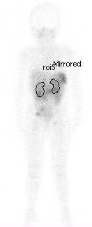
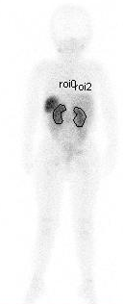
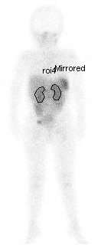
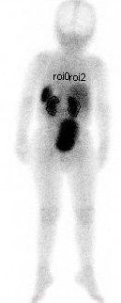
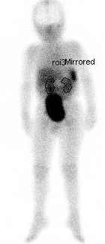
The anterior and posterior images at each time point are shown below. On each image are shown the irregular regions of interest over the left and right kidney. The counts from each region are recorded in the spreadsheet.
Post
Post
Ant
Ant
Anterior
Posterior
- Using the data in the spreadsheet calculate the geometric mean count for the left and right kidney at each time point. Thus, using the sensitivity value provided, calculate the activity in the left and right kidney at each time point. (Note: acquisition time for WB scan is 240s per pixel). Sum the activities to obtain the total activity in both kidneys at each time point.
SPECT/CT Imaging
Three SPECT/CT imaging sessions were acquired for this patient, with 120 projections of 30 seconds per projection. Both attenuation correction (CT) and scatter correction were performed in the iterative reconstruction.

Delineation of each kidney has been performed by manually drawing ROIs around the organ on the CT images, then copying across to the corresponding NM slice.
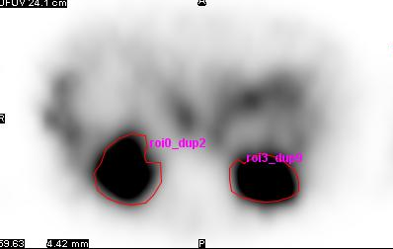
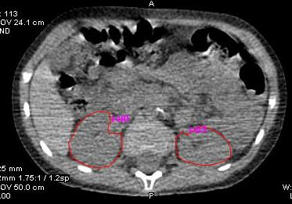
For each NM slice, ROI area and counts within the ROI are recorded in the spreadsheet. The slice thickness of NM imaging is 4.42mm. The sensitivity value is 2.9 cps/MBq. This has been obtained using a calibration scan of the largest sphere (26.5 ml) in the PET NEMA IQ phantom, reconstructed identically to the patient images.
- Using the data in the SPECT Imaging worksheet, calculate the activity, volume, and mass of each kidney at each time point, then sum the values for both kidneys. Calculate the average kidney mass (both kidneys) across the three SPECT/CT scans.
- Compare the activities calculated using the WB scans and SPECT/CT imaging. What factors may have caused the differences between the two? Which result do you think is more accurate? What are the advantages and disadvantages of each method?

- Would the SPECT sensitivity value used here be appropriate for activity quantification of a small lesion (< 5 ml)? How about for a large volume, such as the liver? If not, how could an appropriate value be obtained?
Curve Fitting
Move to the ‘Curve Fitting’ worksheet and enter the calculated activities for both kidneys combined in the relevant cell for both WB and SPECT for all 3 scans.
- Fit a mono-exponential curve to the data points (separately for both the WB data and the SPECT data) using Excel SOLVER. Select the 'Data' tab and the SOLVER application is on the far right hand side. Set the objective to minimise the sum of squared differences between measured and fitted activity by changing the variables A₀ and λ. Use a GRG Non-linear solving method.

- Calculate the Cumulated Activity$(\tilde{A}$) for both WB and SPECT data.
$$Cumulated Activity \left(MBq.hrs\right)= \frac{A_{0}(MBq)}{λ ({hrs}^{-1})}$$
- A more complex curve fit of the SPECT data might include an uptake phase. What effect might this have on the calculated cumulated activity?
Move to the ‘Dose Calculation’ worksheet. Input the cumulated activities calculated on the previous sheet.
- Calculate the absorbed dose for both WB and SPECT data using the provided Dose Factor (from OLINDA v1.0, Lu-177 self-dose using 5 year old phantom model).
- For the SPECT data, scale the dose factor using the ratio of the measured patient kidney mass and the model kidney mass, then calculate the absorbed dose using this scaled factor.
For this patient, the intention is to give 4 fractions of ¹⁷⁷Lu-DOTATATE, with the activities prescribed so as to keep the cumulative kidney dose below 23Gy.The administered activity for the first fraction was 1166 MBq.
- For the SPECT/C- derived mass-scaled dose, calculate the kidney dose per unit administered activity (Gy/MBq). Given the dose constraint of 23Gy, estimate the maximum activity per fraction that can be administered for 3 further fractions of ¹⁷⁷Lu-DOTATATE (assuming no other organ dose limits are exceeded).

- The 23 Gy kidney dose limit is derived from data from patients receiving external beam Radiotherapy, and may not be appropriate for Molecular Radiotherapy with Lu-177. How could kidney toxicity be clinically monitored following treatment?

